# Apply filters to SQL queries

## Project description

I used SQL to query an organization’s employees and log_in_attempts tables to retrieve login attempts and employees information to ensure that the system is safe and no abnormalities are overlooked. The following steps provide examples of how I used SQL with filters to perform security related queries on these tables.

## Retrieve after hours failed login attempts

There was a potential security issue that occurred after business hours (18:00). Due to this we have to investigate all login attempts past work hours. The following code demonstrates how I used SQL to query for these failed login attempts using the log_in_attempts table.

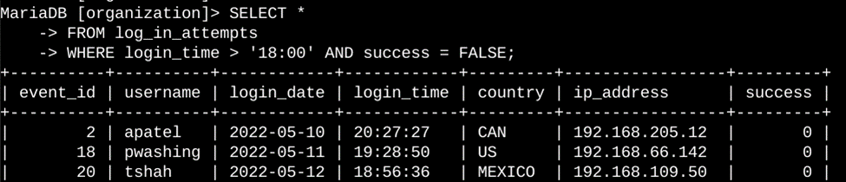

I selected all columns from the log_in_attempts table and filtered the table for login attempts past 18:00 that were failed login attempts by setting the filter for the success column to be FALSE.

## Retrieve login attempts on specific dates

A suspicious event occurred on 2022-05-09. Any login activity that happened on 2022-05-09 or on the day before needs to be investigated.

The following code demonstrates how I used SQL to query and filter for login attempts on these dates:

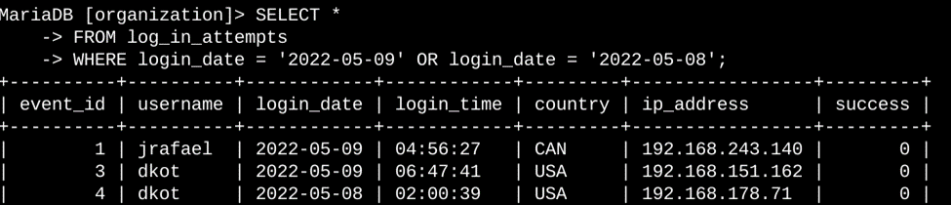

I selected all columns from the log_in_attempts table and filtered the login_date using the WHERE clause to return login dates from 2022-05-09 and 2022-05-08 using the OR operator to filter for those dates only.

## Retrieve login attempts outside of Mexico

After investigating the organization’s data on login attempts, I believe there is an issue with the login attempts that occurred outside of Mexico. The following code demonstrates how I created a SQL query to filter for login attempts that occurred outside of Mexico:

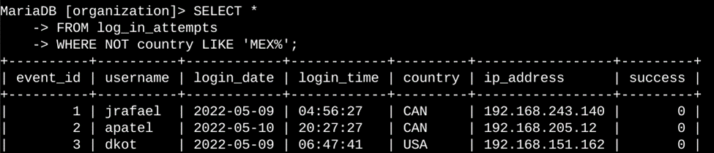

This query returns all login attempts that occurred in countries other than Mexico. I selected all columns from the log_in_attempts table using the. Using the WHERE clause and NOT operator I filtered for countries other than Mexico to be outputted. To ensure Mexico and its different variations of spelling (ex. MEX) are not included in the query. I used the LIKE operator with ‘MEX%’ as the pattern. The percentage sign (%) represents any number of unspecified characters when used with LIKE.

## Retrieve employees in Marketing

This task required the updating of computers for the Marketing department. To do this I have to get information on which employee machines need to be updated. From the information given to me I know that I need to grab the information of employees in the Marketing department who are in the East building. The following is the SQL code I used to query for this information.

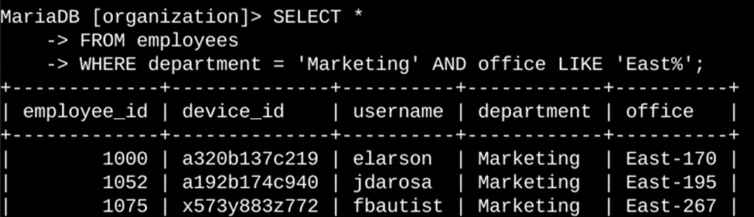

This query returns all employees in the Marketing department in the East building. I selected all columns from the employees table and used the WHERE clause to filter the department to only return information from employees in Marketing. I then used LIKE and East% for the pattern to return all employees who are in the East building.

## Retrieve employees in Finance or Sales

The machines for employees in the Finance and Sales departments also need to be updated. Since a different security update is needed, I have to get information on employees only from these two departments.

The following code demonstrates how I created a SQL query to filter for employee machines from employees in the Finance or Sales departments.

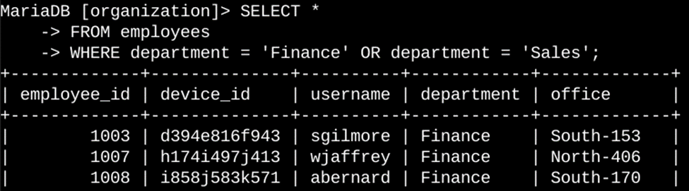

This query returns all employees in the Finance and Sales departments. I selected all data columns from the employees table. Then I used a WHERE clause with the OR operator to filter for employees who are in the Finance and Sales department. I used the OR operator instead of AND because I want all employees who are in either department. The first condition, department = ‘Finance’ filters for employees from the Finance department. The second condition, department = ‘Sales’ filters for employees from the Sales department.

## Retrieve all employees not in IT

My team needs to make one more security update on employees who are not in the Information Technology department. To make the update, I first have to get information on these employees.

The following demonstrates how I created a SQL query to filter for employee machines from employees not in the Information Technology department:

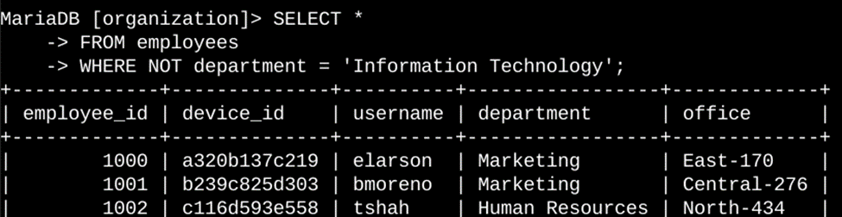

This query returns all employees not in the Information Technology department. I selected all columns from the employees table. Then I used a WHERE clause with the NOT operator to filter for all employees who are not in the Information Technology department. The NOT

## Summary

I applied filters to SQL queries to get specific information on login attempts and employee machines. I used two different tables, log_in_attempts and employees. I used the AND, OR, and NOT operators to filter for the specific information needed for each task. I also used LIKE and the percentage sign (%) wildcard to filter for patterns.